National University of Computer and Emerging Sciences, Lahore Campus

 | Course: | Digital Logic Design | Course Code: | EE227
 | Program: | BS(Computer Science) | Semester: | Fall 2018
 | Duration: | 25 Minutes | Total Marks: | 15
 | Paper Date: |  | Weight:
 | Section: | A | Page(s):
 | Exam: | Quiz-3 | Roll Number

Show your working otherwise no credit will be given.

Q1) Fill the following table for the given circuit [5 marks]
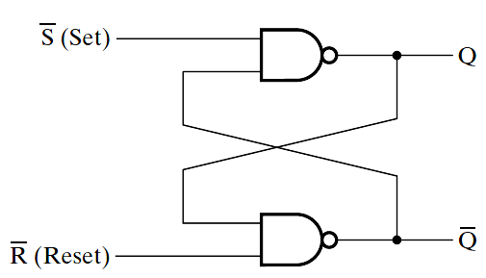

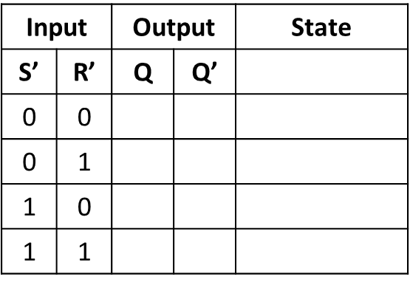

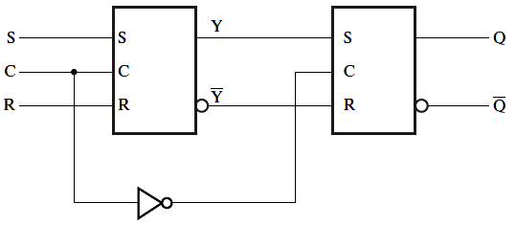

Q2) Complete the timing diagram for the above circuit [5 marks]

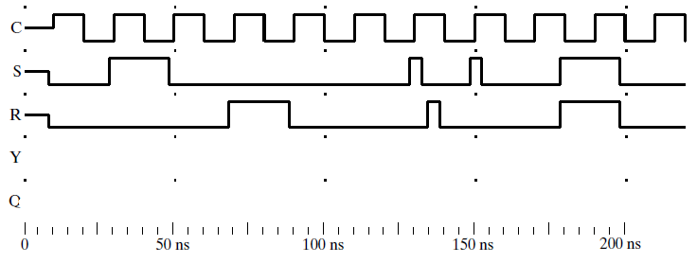
Q3. Determine the following function implemented using a multiplexer. Write minterms only e.g., ∑m(31,32,33,34,35,36) [5 marks]

4-to-1 MUX

S1 S0

C 1
F(A,B,C,D)
D

D

C
A B
D

F (A,B,C,D) =

